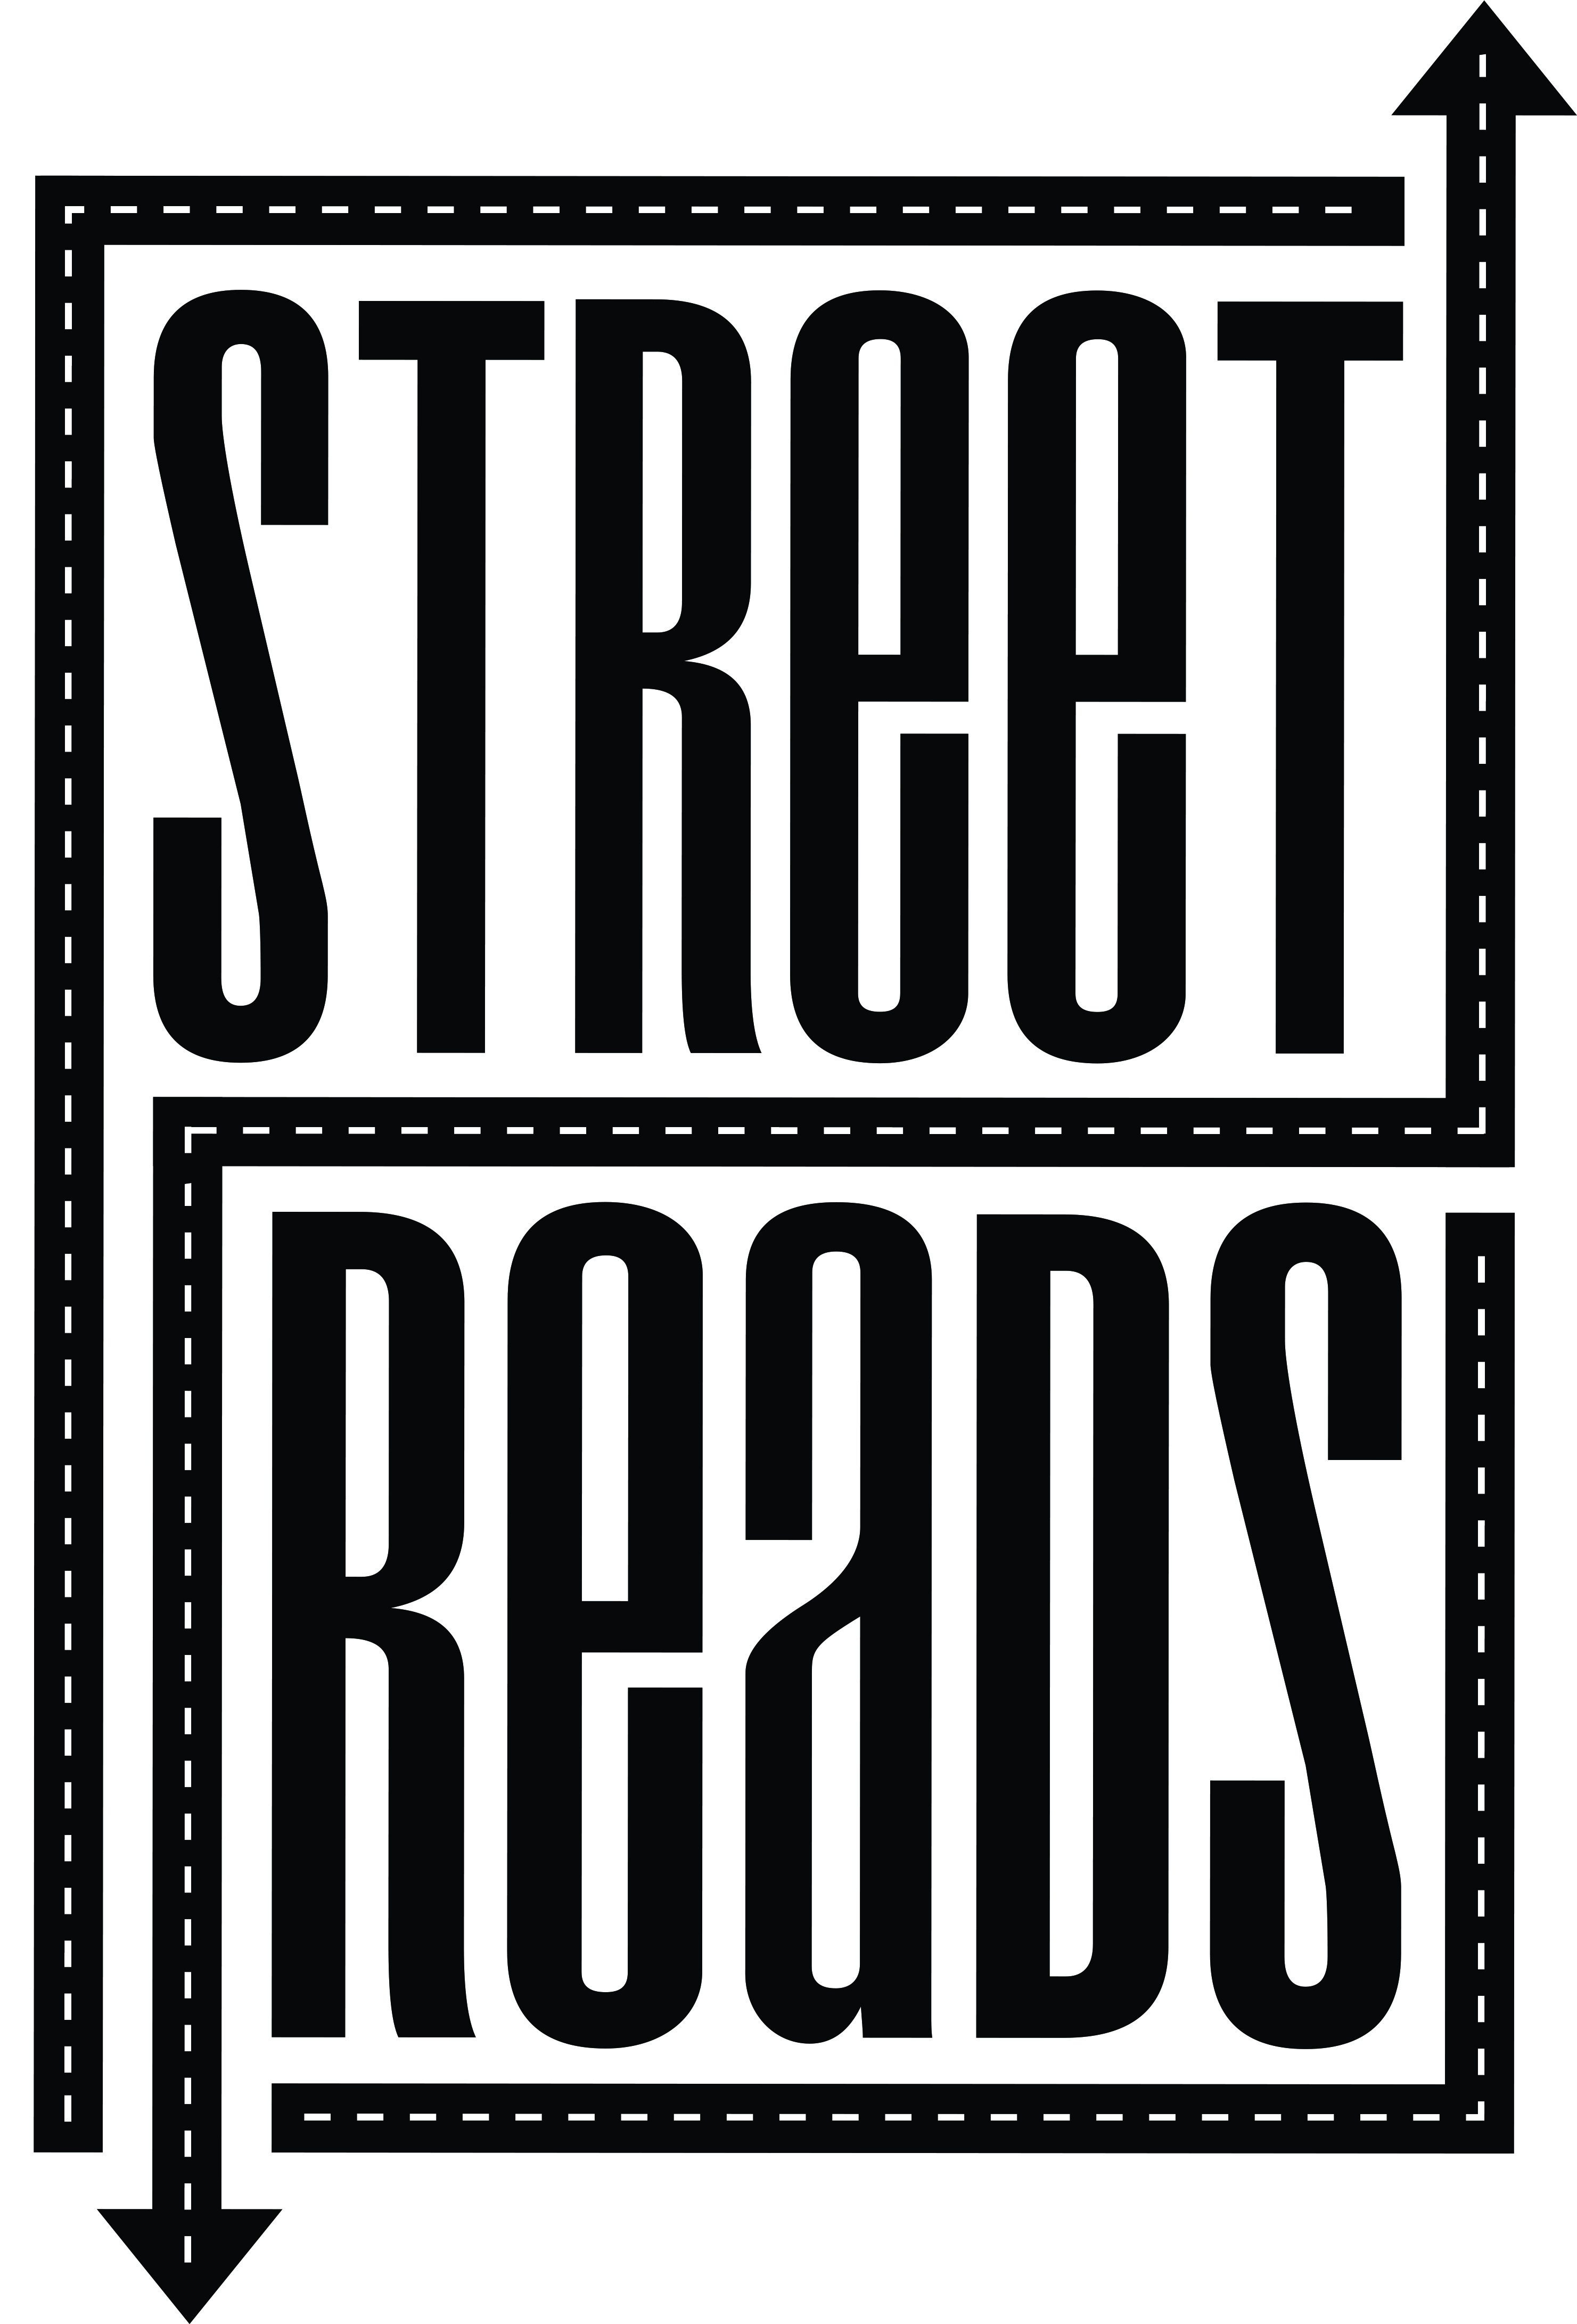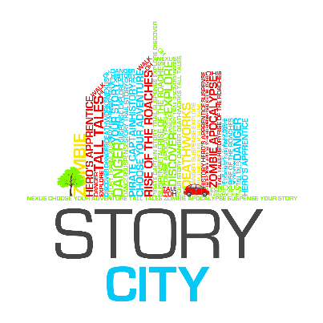

2015 Street Reads
ARTIST/MUSICIAN Expression of Interest APPLICATION FORM

Date of Application:

Contact Name:

Organisation:

Postal Address:

Street / Physical Address:

Phone / Fax Numbers:

Website:

Email:
ABN:  Are you registered for GST? | ☐ Yes  ☐ No
Qualifications: | Attach your CV to your email (max 2 pages). Note here the name of this attachment.
Supporting Documentation: | List any additional documents you are attaching in support of your Expression of Interest. (Max 3 images 1mb each or 3 piece of music under 2mb each). You will be asked to include URLs and links to online information or support material in a later section of the form.

Call for Expressions of Interest
Information Sheet

ABOUT STORY CITY

Story City is a digital storytelling experience that puts you in the story. It combines fictional choose-your-own-adventure style stories with physical locations, allowing the fantasy to become ‘real’ to the adventurer. The Story City GPS app allows us to deliver a story in the location it is set and to augment the story with images and soundtracks.

ABOUT COUNCIL

Brisbane City Council is dedicated to building a vibrant creative city that values ideas, cooperation and cultural diversity. It supports creative industries, festivals both small and large to bring people together to share their stories, music, art and food.

STREET READS 2015
To Be Launched September 2015

An interactive Choose Your Own Story adventure narrative through Brisbane Suburbs. Street Reads takes the reading experience from the traditional printed page and delivers it to smart phones and mobile devices. Through the Story City locative app, readers are guided on a trail to unravel and explore a story of their own choosing.

In previous years Street Reads has been run in the CBD and in South Bank, but this year we want to take Street Reads out into the suburbs of Brisbane, showcasing the other vibrant sections of our city.

Street Reads will showcase the work of three local writers as well as an illustrator and musician. Street Reads is presented by Story City and an initiative of the Brisbane City Council.

BRIEF

Story City are seeking one artist and one musician to participate in Brisbane City Council’s Street Reads alongside selected writers. The idea is to enhance the Choose Your Own Adventure style stories with graphic and musical elements. See the following Street Reads website pages for an idea of previous artwork and music. Artwork: http://streetreads.com/art/ ; Music: http://streetreads.com/music-2014/

Once the three writers complete their adventures, the artist will create illustration or create graphic elements for each story for use in the Street Reads project. While the graphics will include fictional/imagined elements, you need to be proficient in creating graphics/illustrations of recognisable real world landscapes as the Street Reads stories are location based. There will be 45-48 illustrations in all.

The musician will create instrumental or sound elements to build/enhance mood and suspense for each story for use in the Street Reads project. Think of it as creating a soundtrack as a backing to the voice narration. For musical creations you can use voice elements but it is preferred that your final songs be free of lyrics. Composers are highly encouraged to apply (as long as they are able to record and produce the songs they compose for the project). We will give preference to musicians who show they can be versatile in their composition, your music needs to be adaptable to three completely different stories in different genres. One might be a ghost story, the other a love story and the next an action adventure, so just keep that in mind. You will need to create music for 45 locations (3-4 mins each).

Expressions of interest are to include:
- Completed Application Form (see above and below – please rename the file with your first and last name)
- Current CV (maximum 2 pages – please name your file “CV your name”)
- Up to 3 examples of your illustrative, graphic or musical work (music to be 30 seconds to 1 minute in length)

The artist and musician will work with three selected writers and Street Reads producer, Emily Craven, to develop work for use in the Choose Your Own Adventure style stories.

To be eligible, the artist and musician must be based in Brisbane, be able to attend a 3 hour morning workshop in June (between Monday 8th and Friday 12th June, exact date TBC), and a walk around with the Producer in selected Brisbane suburbs in the week after the workshop. The artist and musician must be willing to align with Council’s values and create work in a short timeframe suitable for a public space and appropriate for a wide ranging audience.

The work created will appear on the Story City app, Story City Website, Street Reads and Council’s website, in promotional material, on Council’s Social media channels and in media briefings, etc.

SELECTION

The artist and musician will be selected by Street Reads producer, Emily Craven, with input by Brisbane City Council staff.

PAYMENT

A $2,000 fee (inclusive of GST) will be paid to the artist and a $2,500 fee (inclusive of GST) will be paid to the musician for the development of new work for use in the Street Reads project. This fee includes attendance at a development workshop and walk arounds and associated expenses in the development of the work i.e. recording fees/expenses or art materials are to be included in the payment.

CONTACT

For further information or enquiries, please contact Emily Craven, Street Reads Producer at ecraven@storycity.com.au

SUBMITTING YOUR EXPRESSION OF INTEREST

Submissions should be emailed to: ecraven@storycity.com.au with “Street Reads Artist/Musician EOI” in the Subject line. Please email your:

Completed expression of interest application form

Current CV (maximum 2 pages)
- Up to three examples of your illustrative, graphic or musical work (music to be 30 seconds to 1 minute in length)

The deadline to submit your Expression of Interest is 10am Monday 25 May 2015.

Applicants should expect a response to their expression of interest by COB Thursday 28 May 2015. All shortlisted applicants are expected to attend the 3 hour workshop and a walk through the potential sites for the stories. If you cannot attend the workshop we will take that to mean you are withdrawing your application. Any commercial or artistic information you have supplied for this application will be regarded as confidential and any personal details will be dealt with in accordance with the Council’s Privacy Policy.

ARTIST/MUSICIAN RESPONSE

Briefly describe why you would like to be the artist/musician for Street Reads.
(max 150 words)
Consider your:
- Inspiration/passions
- artistic style and skill
- Connection to Brisbane
- What it is about Brisbane that makes you want to bring it to life
- How it will affect/influence your career
Please provide links to examples of your work online. Alternatively, you may attach a maximum of 3 images/mp3 files of support material to your application form. | URL:  URL:  URL:  Facebook:  YouTube:  Soundcloud:
Preferred availability to attend a 3 hour workshop between Monday 8 June – Friday 12 June 2015. | Day:  Time:

