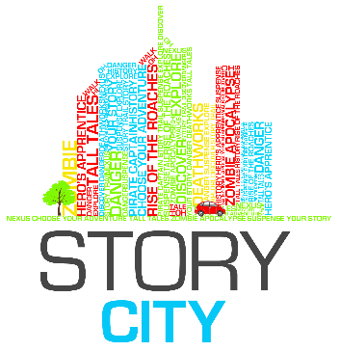

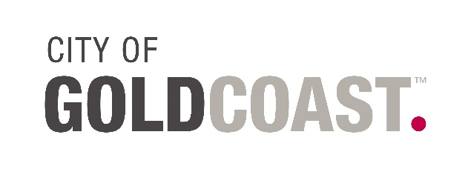

Gold Coast – Choose Your Adventure
ARTIST/MUSICIAN Expression of Interest APPLICATION FORM

Date of Application:

Contact Name:

Organisation (if applicable):

Postal Address:

Street / Physical Address:

Phone / Fax Numbers:

Website:

Email:
ABN:  Are you registered for GST? | ☐ Yes  ☐ No
Qualifications: | Attach your CV to your email (max 2 pages). Please name your attachment using the following syntax: [Your Name] – CV. This document can be a PDF or Word document.
Supporting Documentation: | List any additional documents you are attaching in support of your Expression of Interest. (Max 3 images 1mb each or 3 piece of music only 1min long each and under 2mb in size). You will be asked to include URLs and links to online information or support material in a later section of the form.
Available for workshop? | The workshop will be held on Monday 24th of August 2015. If you are shortlisted for Story City – Gold Coast you must attend the 2-3hr Professional Development workshop. This is where we make our final decision on who will be a part of the Story City – Gold Coast team. If you can’t attend the workshop please email us to withdraw your application.  ☐ Yes  ☐ No
Available for Walk-a-round? | If you make it in the final Story City - Gold Coast team you will need to join the walk around where we walk through the story locations as a team checking out sites and discovering features to include in the stories. This makes the stories as immersive an experience as possible. The walk-a-round normally takes 4-5hrs and is scheduled for Sunday the 30th of August.  ☐ Yes  ☐ No

Please Read FULL EOI Information.
The Application FORM Continues at the end of this document.

Call for Expressions of Interest
Information Sheet

ABOUT STORY CITY

Story City is a digital storytelling experience that puts you in the story. It combines fictional choose-your-own-adventure style stories with physical locations, allowing the fantasy to become ‘real’ to the adventurer. The Story City GPS app allows us to deliver a story in the location it is set. Find out more or download the app at www.storycity.com.au

ABOUT CITY OF GOLD COAST COUNCIL

The City of Gold Coast relies on our vibrant artists and creative thinkers to lead the cultural charge in our rapidly evolving city. We are a community that tells our stories and values our heritage. We are a city creating opportunity for our local artists, creative industries and our citizens. The City of Gold Coast's Culture Strategy 2023 outlines a future where culture is central to our community wellbeing, our city's reputation and liveability and our economic growth. To stay up to date with the latest opportunities, news and information, follow us on Facebook, Twitter or visit cultural.goldcoast.qld.gov.au

GOLD COAST – CHOOSE YOUR ADVENTURE 2015
To Be Launched December 2015

An interactive Choose Your Own Story adventure narrative through Gold Coast Suburbs. Story City – Gold Coast takes the reading experience from the traditional printed page and delivers it to smart phones and mobile devices. Through the Story City locative app, readers are guided on a trail to unravel and explore a story of their own choosing.

Story City – Gold Coast will showcase the work of three local writers as well as an illustrator and musician. Story City – Gold Coast is presented by Story City and funded by the Regional Arts Development Fund. The Regional Arts Development Fund is a Queensland Government and City of Gold Coast Council partnership to support local arts and culture.

BRIEF

Story City are seeking one artist and one musician to participate in Story City – Gold Coast alongside selected writers. The idea is to enhance the Choose Your Own Adventure style stories with graphic and musical elements. See the following Street Reads website pages for an idea of previous artwork and music. Artwork: http://streetreads.com/art/ ; Music: http://streetreads.com/music-2014/

Once the three writers complete their adventures, the artist will create illustration or create graphic elements for each story for use in the Story City – Gold Coast project. While the graphics will include fictional/imagined elements, you need to be proficient in creating graphics/illustrations of recognisable real world landscapes as the Street Reads stories are location based. There will be 45-48 illustrations in all.

The musician will create instrumental or sound elements to build/enhance mood and suspense for each story for use in the Story City – Gold Coast project. Think of it as creating a soundtrack as a backing to the voice narration. For musical creations you can use voice elements but it is preferred that your final songs be free of lyrics. Composers are highly encouraged to apply (as long as they are able to record and produce the songs they compose for the project). We will give preference to musicians who show they can be versatile in their composition, your music needs to be adaptable to three completely different stories in different genres. One might be a ghost story, the other a love story and the next an action adventure, so just keep that in mind. You will need to create music for 45 locations (3-4 mins each).

The artist and musician will work with three selected writers and Story City – Gold Coast producer, Emily Craven, to develop work for use in the Choose Your Own Adventure style stories.

To be eligible, the artist/composer/musician must be based in the City of Gold Coast Council area, be able to attend a 3 hour workshop on the 24th of August, and a walk around with the Producer in the selected suburbs on Sunday the 30th of August. The artist and musician must be willing to create work in a short timeframe suitable for a public space and appropriate for a wide ranging audience.

If successful, the artist and musician will participate in a workshop to develop skills in writing for interactive delivery, participate in site visits and develop new based on the writer’s stories that will be presented during the month of December 2015.

The written work will appear on the Story City app, Story City Website, Arts QLD and Council’s websites, in promotional material, on Social media channels and in media briefings, etc.

SELECTION

The artist and musician will be selected by Story City – Gold Coast producer, Emily Craven.

PAYMENT

A $2,000 fee (inclusive of GST) will be paid to the artist and a $2,500 fee (inclusive of GST) will be paid to the musician for the development of new work for use in the Story City – Gold Coast project. This fee includes attendance at the site visits and associated expenses in the development of the work i.e. recording fees/expenses or art materials are to be included in the payment.

CONTACT

For further information or enquiries, please contact Emily Craven, Street Reads Producer at ecraven@storycity.com.au

SUBMITTING YOUR EXPRESSION OF INTEREST

Submissions should be emailed to: ecraven@storycity.com.au with “Story City – Gold Coast Artist/Musician EOI” in the Subject line. Please email your:
- Completed Application Form (see above and below – please rename the file with your first and last name)
- Current CV (maximum 2 pages – please name your file: “Your name - CV”)
- Up to 3 examples of your illustrative, graphic or musical work (music to be 30 seconds to 1 minute in length)

The deadline to submit your Expression of Interest is 11:59pm Monday 17th August 2015.

Applicants should expect a response to their expression of interest by COB Wednesday 19th August 2015. All shortlisted applicants are expected to attend the 3 hour workshop. If you cannot attend the workshop we will take that to mean you are withdrawing your application. Any commercial, personal or artistic information you have supplied for this application will be regarded as confidential.

ARTIST/MUSICIAN RESPONSE

Briefly describe why you would like to be the artist/musician for Story City – Gold Coast.
(max 150 words)
Consider your:
- Inspiration/passions
- Artistic style and skill
- Connection to Gold Coast
- What it is about the Gold Coast that makes you want to bring it to life
- How it will affect/influence your career
Please provide links to examples of your work online. Alternatively, you may attach a maximum of 3 images/mp3 files of support material to your application form. | URL:  URL:  URL:  Facebook:  YouTube:  Soundcloud:
I am able to attend a 10am-1pm, 3 hour workshop on Monday the 24th of August | ☐ Yes  ☐ No

