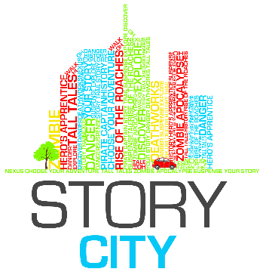

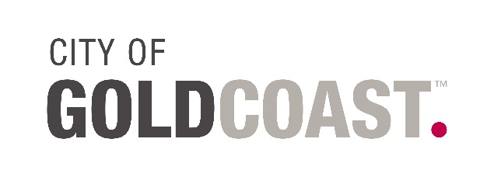

Gold Coast – Choose Your Adventure

WRITER Expression of Interest APPLICATION FORM

Date of Application:

Contact Name:

Organisation:

Postal Address:

Street / Physical Address:

Phone / Fax Numbers:

Website:

Email:
ABN:  Are you registered for GST? | ☐ Yes  ☐ No
Qualifications: | Attach your CV to your email (max 2 pages). Please name your attachment using the following syntax: [Your Name] – CV. This document can be a PDF or Word document.
Supporting Documentation: | List any additional documents you are attaching in support of your Expression of Interest (PDF or Word doc preferred). Please rename your documents with the following syntax: [Your Name] – [Name of piece]. You may attach 5 pages (around 1000 words) of writing examples. Please do not send us to online links, attached documents only.
Available for workshop? | The workshop will be held on Monday 24th of August 2015. If you are shortlisted for Story City – Gold Coast you must attend the 2-3hr Professional Development workshop. This is where we make our final decision on who will be a part of the Story City – Gold Coast team. If you can’t attend the workshop please email us to withdraw your application.  ☐ Yes  ☐ No
Available for Walk-a-round? | If you make it in the final Story City - Gold Coast team you will need to join the walk around where we walk through the story locations as a team checking out sites and discovering features to include in the stories. This makes the stories as immersive an experience as possible. The walk-a-round normally takes 4-5hrs and is scheduled for Sunday the 30th of August.  ☐ Yes  ☐ No

Please Read FULL EOI Information.
The Application FORM Continues at the end of this document.

Call for Expressions of Interest

Information Sheet

ABOUT STORY CITY

Story City is a digital storytelling experience that puts you in the story. It combines fictional choose-your-own-adventure style stories with physical locations, allowing the fantasy to become ‘real’ to the adventurer. The Story City GPS app allows us to deliver a story in the location it is set. Find out more or download the app at www.storycity.com.au

ABOUT CITY OF GOLD COAST COUNCIL

The City of Gold Coast relies on our vibrant artists and creative thinkers to lead the cultural charge in our rapidly evolving city. We are a community that tells our stories and values our heritage. We are a city creating opportunity for our local artists, creative industries and our citizens. The City of Gold Coast's Culture Strategy 2023 outlines a future where culture is central to our community wellbeing, our city's reputation and liveability and our economic growth. To stay up to date with the latest opportunities, news and information, follow us on Facebook, Twitter or visit cultural.goldcoast.qld.gov.au

GOLD COAST – CHOOSE YOUR ADVENTURE 2015
To Be Launched December 2015

An interactive Choose Your Own Story adventure narrative through Gold Coast Suburbs. Story City – Gold Coast takes the reading experience from the traditional printed page and delivers it to smart phones and mobile devices. Through the Story City locative app, readers are guided on a trail to unravel and explore a story of their own choosing.

Story City – Gold Coast will showcase the work of three local writers as well as an illustrator and musician. Story City – Gold Coast is presented by Story City and funded by the Regional Arts Development Fund. The Regional Arts Development Fund is a Queensland Government and City of Gold Coast Council partnership to support local arts and culture.

BRIEF

Story City are seeking three writers to participate in Gold Coast – Choose Your Adventure. The idea of the Story City – Gold Coast project is to create location based stories or adventures, meaning that each story section happens in the location the reader is standing.

Each writer will produce a Choose Your Own Story style adventure narrative with five levels (15-16 locations in all) of choice for the reader. As the writer you will need to incorporate your nominated locations, art and interesting features into your fictional stories. These stories can be set in the area of your choice, some potential areas you might set your story in are: Southport, Coolangatta, Burleigh, Surfers Paradise, Mudgeeraba etc.

Previous Story City adventures have included narratives of alien invasion, Sherlock Holmes style mysteries, zombie apocalypses, ghost stories, pirate tales and virtual reality versions of a city. Remember, whether it is running from animal facades that have come to life, or stopping an invasion, or searching for a devious spy who stole state secrets, your stories must involve the readers/participants in the adventures.

Part of this project will include professional development in the form of a workshop helping you to create, write and structure your story (if you have never written one before, do not worry, we will make sure you are ready), and possible opportunities to give workshops of your own to the community.

Writers will work with Gold Coast – Choose Your Adventure producer and Story City creator, Emily Craven, to develop their work and select appropriate sites for use in the Choose Your Own Story aspect of the project.

To be eligible, the writer must be based in the City of Gold Coast Council area, be able to attend a 3 hour workshop on the 24th of August, and a walk around with the Producer in your chosen suburb on Sunday the 30th of August. The writer must be willing to write a new choose your adventure work in a short timeframe suitable for a public space and appropriate for a wide ranging audience.

If successful, the writer will participate in a workshop to develop skills in writing for interactive delivery, participate in site visits to map the delivery of the work and develop a new written work of fiction that will be presented during the month of December 2015. It is estimated by previous authors who have worked on our projects that the site visits and creation of their story took between 20-30 hrs of their time.

The written work will appear on the Story City app, Story City Website, Arts QLD and Council’s websites, in promotional material, on Social media channels and in media briefings, etc.

SELECTION

Writers will be selected by Story City – Gold Coast producer, Emily Craven.

PAYMENT

A $1,500 fee (inclusive of GST) will be paid to each writer for the development of a new written work and the use of the work in the Story City – Gold Coast project. This fee grants Story City a 3-year exclusive license to use and promote the work, and it is expected to cover the writer’s research on site for mapping their story thread and the creation of the story.

SUBMITTING YOUR EXPRESSION OF INTEREST

Submissions should be emailed to: ecraven@storycity.com.au with “Story City – Gold Coast Writer EOI” in the Subject line. Please email your:

Completed expression of interest application form (rename the file with your first and last name)

Current CV (maximum 2 pages) (name your file: Your Name - CV)

Any supporting material, max. 5 pages (for example a sample of writing for this potential story or of a previous story you have written that may be very strong in place etc).

The deadline to submit your Expression of Interest is 11:59pm Monday 17th August 2015.

Applicants should expect a response to their expression of interest by COB Wednesday 19th August 2015. All shortlisted applicants are expected to attend the 3 hour workshop. If you cannot attend the workshop we will take that to mean you are withdrawing your application. Any commercial, personal or artistic information you have supplied for this application will be regarded as confidential.

CONTACT

For further information or enquiries, please contact Emily Craven, Story City – Gold Coast Producer at ecraven@storycity.com.au

WRITER RESPONSE

Briefly describe why you would like to be a writer for Story City – Gold Coast.
(max 150 words)
Consider your:
- Inspiration/passions
- Your thoughts on digital writing
- Connection to the Gold Coast
- What it is about the Gold Coast that makes you want to bring it to life?
- How it will affect your writing skills/career
What is the story idea you would like to write for Story City - Gold Coast? (Max 700 words) In your proposal please consider:
- Genre and rating (G, PG, M15+)
- Key theme and potential featured characters
- The features of the particular area you have chosen and how they add to your key theme. Note Story City is a GPS app and does not work in indoor locations.
- Remember, the reader is a character in your narrative (and this is a choose your adventure so the narrative will branch in different storylines)
- Suggest some potential different endings.
- End your proposal with a 25 word tag line summarising your story in a way that would entice an audience to participate in your adventure.
List the City of Gold Coast area you would like to activate with your adventure and list some potential locations in that area that could be included in your story (max 15 locations). Please keep in mind:
- This is a City of Gold Coast Council project, it needs to be within the council bounds
- Locations need to be more than random trees or street corners, there needs to be something of note in your location, a reason why the reader would visit other than to do the adventure
- Each reader’s adventure (so a story branch consisting of 4-5 locations) needs to be completed in under 1km. So the locations need to be fairly close to each other and easy to walk between.
- Your locations cannot be indoors as the App works on GPS technology which doesn’t work too well inside!
I can attend the 10am-1pm, 3 hour workshop on Monday the 24th of August | ☐ Yes  ☐ No

