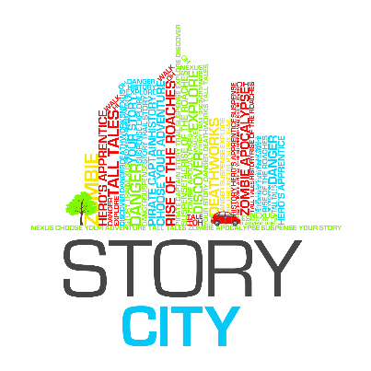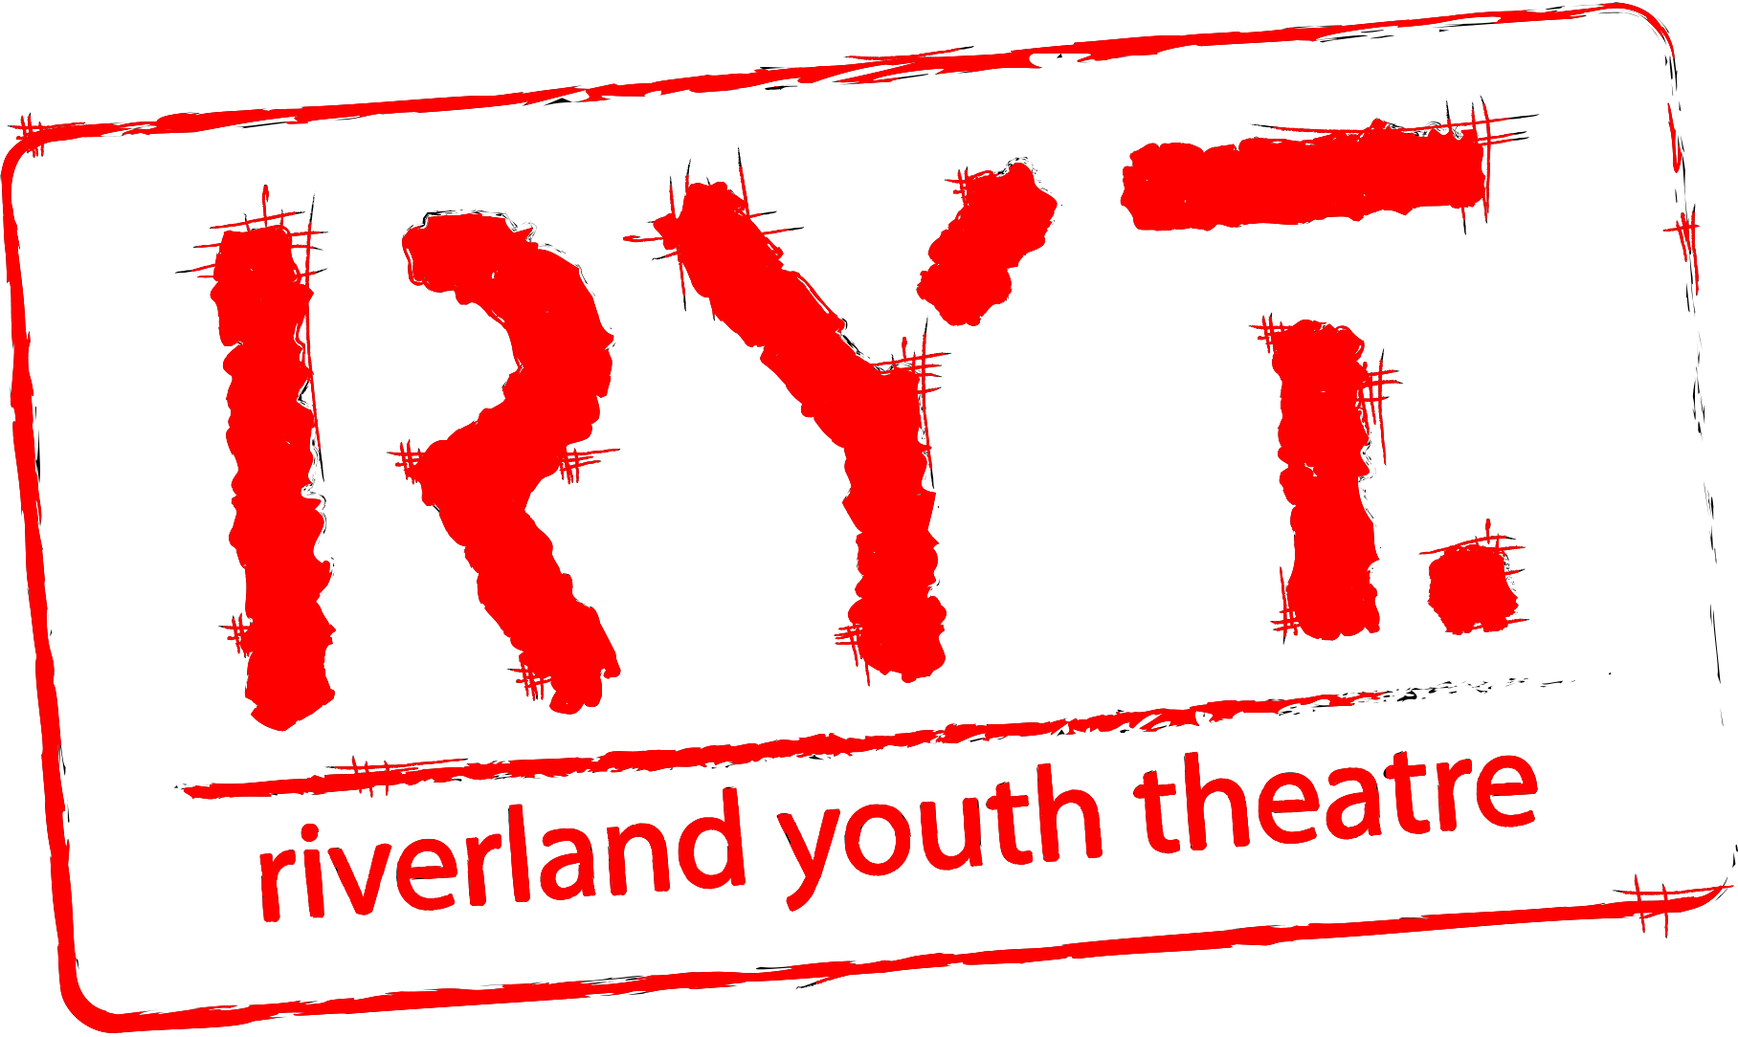

Story City – Story Town Riverland
ARTIST/MUSICIAN Expression of Interest APPLICATION FORM

Date of Application:

Contact Name:

Postal Address:

Street / Physical Address:

Phone Numbers:

Website:

Email:
Experience: | Attach your CV to your email (max 2 pages). Please name your attachment using the following syntax: [Your Name] – CV. This document can be a PDF or Word document. Please note due to the young age group, if you have few projects to include in your CV, then we are happy for you to include in your CV a short 200 word or less blurb about why you believe you will be able to handle this role, and what skills you might have to offer.
Previous Works: | List any previous works you are attaching in support of your Expression of Interest. (Max 3 images 1mb each or 3 piece of music under 2mb each). You will be asked to include URLs and links to online information or support material in a later section of the form. Make sure all files are named using the following syntax: [Your Name] – Image [1/2/3] etc.
Available for workshop? | The workshop will be held on Sunday 10th June 2018. If you are shortlisted for Story City you must attend the workshop. This is where we make our final decision on who will be a part of the Story City team. If you can’t attend the workshop please email us to withdraw your application.  ☐ Yes  ☐ No
Available for Walk-a-round? | If you make it in the final Story City team you will need to join the mentorship day and walk around where we walk through the Berri/Barmera district as a team checking out sites and discovering features to include in the stories etc so we can make this as immersive an experience as possible.  Date: Sunday 17th June 2018  ☐ Yes  ☐ No

Expression of Interest Submission Deadline: 5pm Friday 1st June 2018

Expression of Interest Applications to be sent to (Note there are 2 emails!): chris@ryt.org.au and cc’d in to ecraven@storycity.com.au

NOTE: Please, this is not the end of the information or application, read the WHOLE document and also fill out questions at the end of this document before you submit.

This project was made possible by the Australian Government’s Regional Arts fund, which supports the arts in regional and remote Australia.’

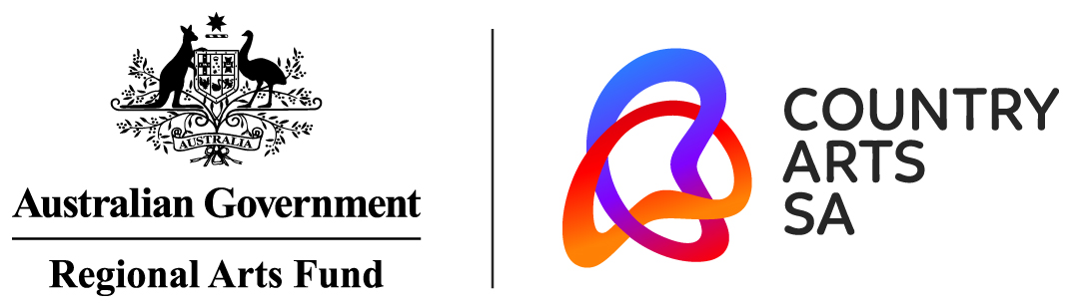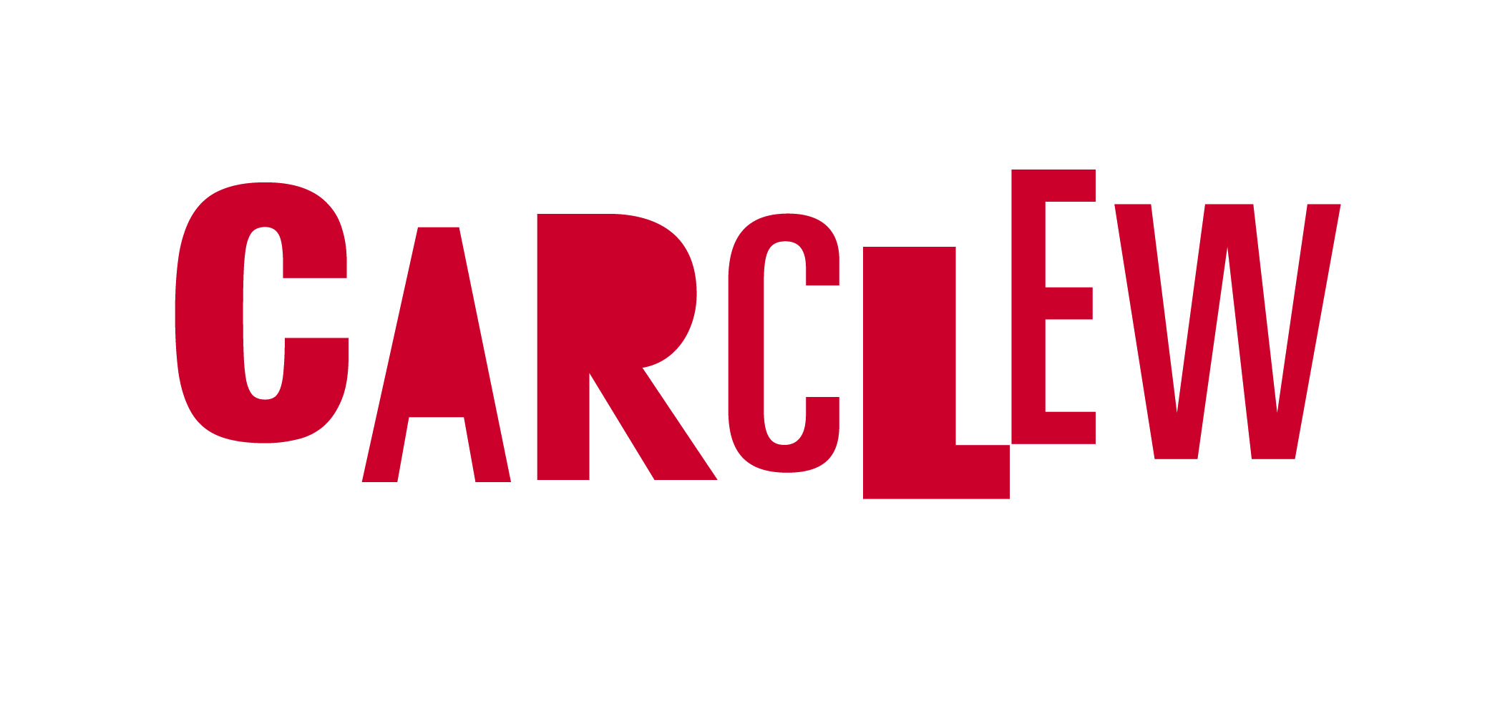

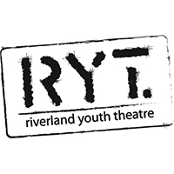
Call for Expressions of Interest
Information Sheet

ABOUT STORY CITY

Story City is a digital storytelling experience that puts you in the story. It combines fictional choose-your-own-adventure style stories with physical locations, allowing the fantasy to become ‘real’ to the adventurer. The Story City GPS app allows us to deliver a story in the location it is set and to augment the narrative with images and soundtracks.

Story City only works with local writers and artists, and to date has provided professional development for 250+ artists, employed 50+ writers and artists, and published 36 interactive stories across Australia.

ABOUT RIVERLAND YOUTH THEATRE

As the only dedicated Youth Arts organisation in the region, Riverland Youth Theatre (RYT) seeks to provide a platform for the positive promotion of youth culture. Activities are tailored to the specific demands of Riverland communities.
RYT offers young people across the Riverland relevant and high quality performing and creative arts experiences. This includes opportunities to develop their own creative expression, increase their performance and technical skills, follow personal career development pathways and produce quality contemporary art that is relevant to them, their cultures and communities.

RYT responds to the culture of the place it inhabits by creating work that provides a voice for its young people and ensures that they are heard. RYT breaks down cultural and geographical barriers by working with the community to respond to the social needs of young people

STORY CITY – Story Town Riverland
To Be Launched October 2018

Story City, with the support of the Riverland Youth Theatre, will be seeking to commission the creation of ONE interactive Choose Your Own Story adventure narrative, centred around the Barmera Area. The story will be available through the free Story City app for at least a year.

Story City takes the reading experience from the traditional printed page and delivers it to smart phones and mobile devices. Through the Story City locative app, readers are guided on a trail to unravel and explore a story of their own choosing. This story will appeal to both locals and tourists, combining fiction, historical fact and personal choice to illuminate the area in a new and exciting way.

Story City will commission a local writer, illustrator, musician, and voiceover narrator to collaborate on the project and deliver something truly unique to the community of Barmera.

BRIEF

Riverland Youth Theatre is seeking ONE visual or digital artist and ONE musician/composer/sound artist to participate in the project alongside a selected writer. The idea is to enhance the Choose Your Adventure style stories with graphic and musical elements.

Once the writer completes their adventure, the artist will create illustrations or graphic elements for each story section. While the graphics will include fictional/imagined elements, you need to be proficient in creating graphics/illustrations of recognisable real world landscapes as the Story City stories are location-based. Each story will require approximately 14-16 illustrations, depending on the number of locations the author chooses. Images need to display at high resolution on a phone or tablet.

The musician will create instrumental or sound elements to build/enhance mood and suspense for each story location. It will be creating a background soundtrack to a narrated audio track. For musical creations you can use voice elements but it is preferred that your final songs be free of lyrics. Composers are highly encouraged to apply (as long as they are able to record and produce the songs they compose for the project).

We will give preference to musicians who show they can be versatile in their composition and can compose across varied genres. The story you are handed to score might be a ghost story, or a love story or an action adventure, so just keep that in mind. You will need to create music for 14-16 locations (4-5 mins each). Re-use of some musical elements across the project is allowed in order to produce the required content for the given payment.

Both the Artist and the Musician will have 4 weeks to complete their content.

THIS EXPRESSION OF INTEREST APPLICATION

Riverland Youth Theatre is opening this EOI up to ANY illustrators or musicians based in the Riverland aged between 12 and 26. We are looking for any artists that have a passion for the Riverland, its community and have an affinity for the Barmera area.

This EOI will be asking you to answer all the questions at the end of this document, as well as attach relevant supporting material such as CVs or examples of previous work.

For an example of previous stories, download the Story City app via the Apple or Android app stores, and either do one of the CBD stories for yourself, or see the “Story City app access instructions – No GPS” document linked on the Story City website on the help page to do one from home.

Submissions should be emailed to both our producers: chris@ryt.org.au and cc in ecraven@storycity.com.au with “Story City – Story Town Riverland Artist/Musician EOI” in the Subject line. Please email your:
- Completed Application Form (Do not miss filling your answers to the questions on the final page below – please rename the file ”Your name – EOI form”)
- Current CV (maximum 2 pages – please name your file “Your name - CV”)
- Up to 3 examples of your illustrative, graphic or musical work (music to be 30 seconds to 1 minute in length)

The artist and musician will work with the selected writers and Story City – Story Town Riverland producers Emily Craven and Christopher Bond, to develop work for use in the Choose Your Adventure style story.

The deadline to submit your Expression of Interest is 5pm Friday 1st June 2018

All shortlisted applicants are expected to attend the 3-4hour workshop and the successful candidates, a walk through the potential sites for your stories. If you cannot attend the workshop we will take that to mean you are withdrawing your application. Any commercial or artistic information you have supplied for this application will be regarded as confidential and any personal details will be dealt with in accordance with Riverland Youth Theatre’s Privacy Policy.

STORY CITY WORKSHOP

To be eligible, the artist and musician must be based in the Riverland, be able to attend a day long workshop on Sunday 10th June. Those who are selected for the final team will be required for a day long mentorship and walk-around of the Barmera area on Saturday 17th June with the Producers to finalise locations and provide material for musicians and artists.

The artist and musician must be willing to align with Riverland Youth Theatre’s values and create work in a 4-week timeframe that is suitable for a public space and appropriate for a wide ranging audience. The work will be available for free on the Story City app for at least a year.

The work created will appear on the Story City app, Story City website, and Riverland Youth Theatre’s website, in promotional material, on Riverland Youth Theatre’s social media channels and in media briefings, etc.

SELECTION

The artists and musicians will be selected following the workshop by Story City – Story Town Riverland producers, Emily Craven and Christopher Bond, with input by Riverland Youth Theatre board.

PAYMENT

A $1000 fee (exclusive of GST) will be paid to the artist (based on a minimum rate of $60 per image) and a $1000 fee (exclusive of GST) will be paid to the musician (based on creation of an hour of music) for provision of the required content.

This fee grants Story City and the Riverland Youth Theatre a 2-year exclusive license to use and promote the work. The associated expenses in the development of the work i.e. recording fees/expenses or art materials, are the artist and musician’s responsibility.

CONTACT

For further information or enquiries, please contact Christopher Bond, Story Town Riverland Producer, at chris@ryt.org.au

Please see next page for application form.

ARTIST/MUSICIAN RESPONSE

Briefly describe why you would like to be the artist/musician for Story City – Story Town Riverland.
(max 250 words)
Consider your:
- Inspiration/passions
- artistic style and skill
- Connection to Barmera area.
- What it is about that area that makes you want to bring it to life
- How it will affect/influence your career
Please provide links to examples of your work online. Alternatively, you may attach a maximum of 3 images/mp3 files of support material to your application form. | URL:  URL:  URL:  Facebook:  YouTube:  Soundcloud:

This project was made possible by the Australian Government’s Regional Arts fund, which supports the arts in regional and remote Australia.’

