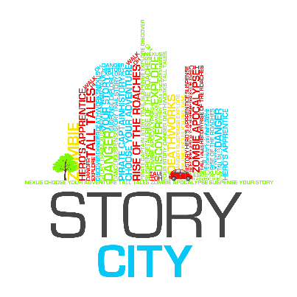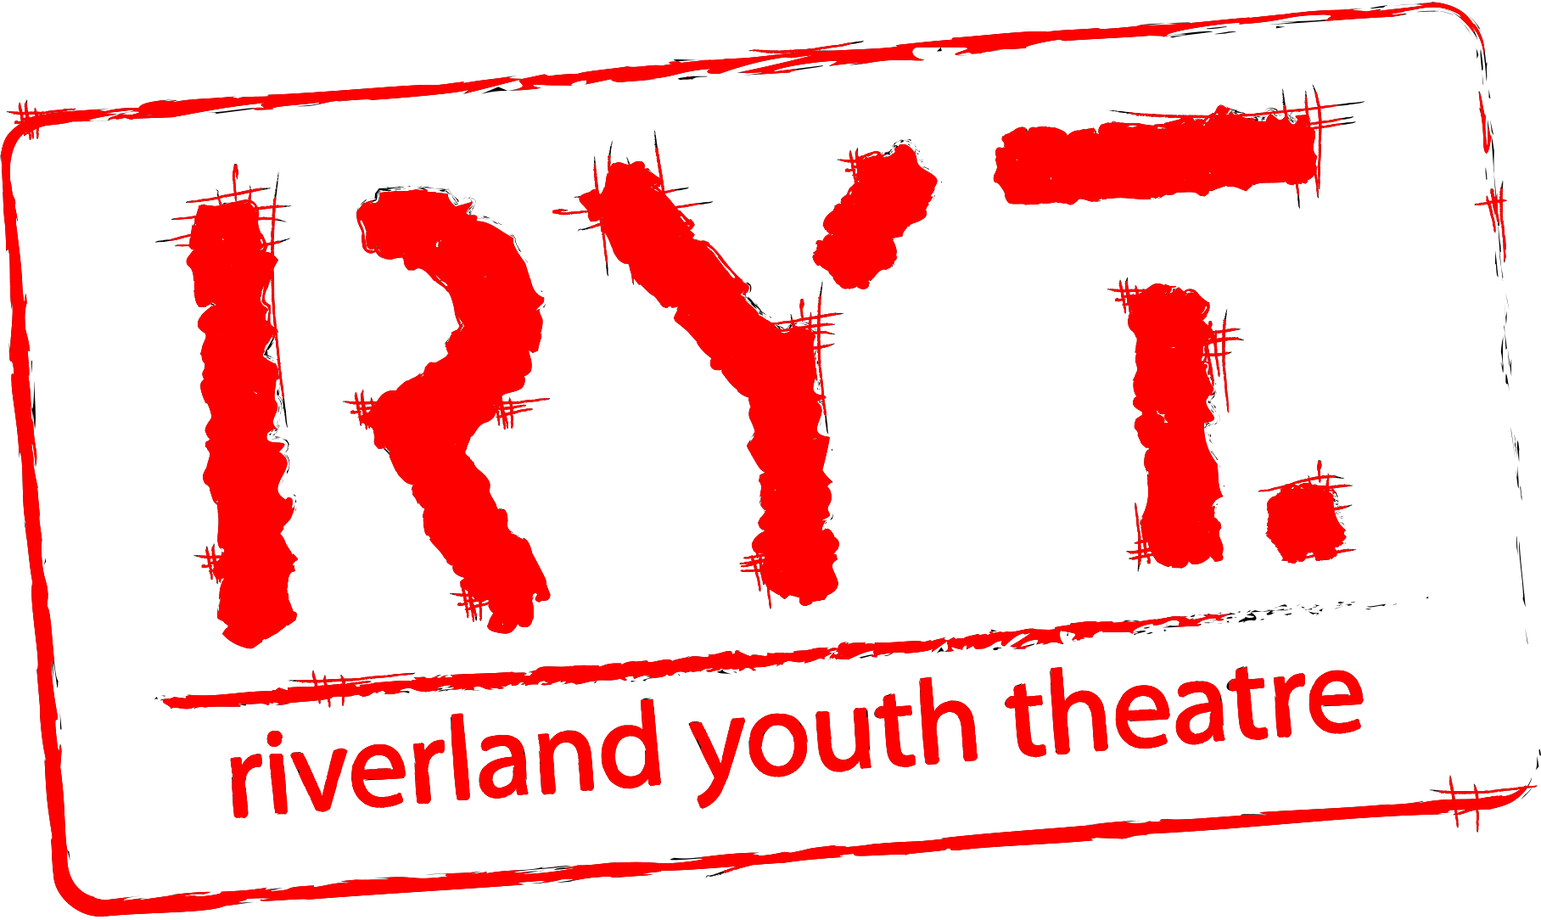

Story City – Story Town Riverland
WRITER Expression of Interest APPLICATION FORM

Date of Application:

Contact Name:

Postal Address:

Street / Physical Address:

Phone Numbers:

Website:

Email:
Experience: | Attach your CV to your email (max 2 pages). Please name your attachment using the following syntax: [Your Name] – CV. This document can be a PDF or Word document. Please note due to the young age group, if you have few projects to include in your CV, then we are happy for you to include in your CV a short 200 word or less blurb about why you believe you will be able to handle this role, and what skills you might have to offer.
Previous Works: | List any additional documents you are attaching in support of your Expression of Interest. You may include URLs and links to examples of your writing online or attach samples to your application email (max 5 pages or 1000 words).
Available for workshop? | The workshop will be held on Sunday 10th June 2018. If you are shortlisted for Story City you must attend the workshop. This is where we make our final decision on who will be a part of the Story City team. If you can’t attend the workshop please email us to withdraw your application.  ☐ Yes  ☐ No
Available for Walk-a-round? | If you make it in the final Story City team you will need to join the mentorship day and walk around where we walk through the Berri/Barmera district as a team checking out sites and discovering features to include in the stories etc so we can make this as immersive an experience as possible.  Date: Sunday 17th June 2018  ☐ Yes  ☐ No

Expression of Interest Submission Deadline: 5pm Friday 1st June 2018

Expression of Interest Applications to be sent to (Note there are 2 emails!): chris@ryt.org.au and cc’d in to ecraven@storycity.com.au

NOTE: Please, this is not the end of the information or application, read the WHOLE document and also fill out questions at the end of this document before you submit.

This project was made possible by the Australian Government’s Regional Arts fund, which supports the arts in regional and remote Australia.’

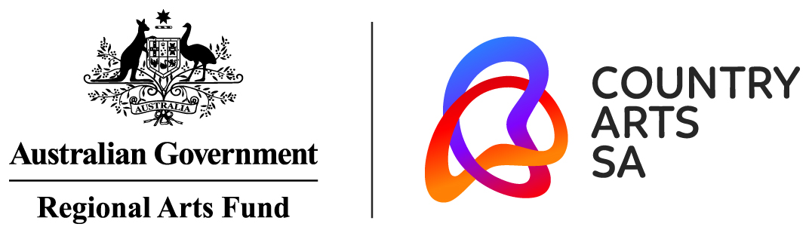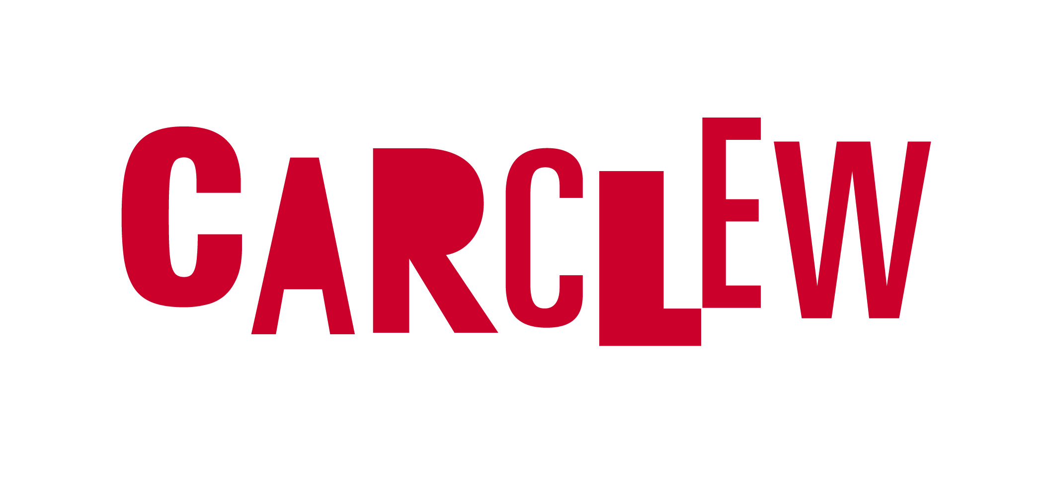

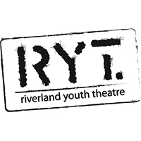
Call for Expressions of Interest
Information Sheet

ABOUT STORY CITY

Story City is a digital storytelling experience that puts you in the story. It combines fictional choose-your-own-adventure style stories with physical locations, allowing the fantasy to become ‘real’ to the adventurer. The Story City GPS app allows us to deliver a story in the location it is set and to augment the narrative with images and soundtracks.

Story City only works with local writers and artists, and to date has provided professional development for 250+ artists, employed 50+ writers and artists, and published 36 interactive stories across Australia.

ABOUT RIVERLAND YOUTH THEATRE

As the only dedicated Youth Arts organisation in the region, Riverland Youth Theatre (RYT) seeks to provide a platform for the positive promotion of youth culture. Activities are tailored to the specific demands of Riverland communities.
RYT offers young people across the Riverland relevant and high quality performing and creative arts experiences. This includes opportunities to develop their own creative expression, increase their performance and technical skills, follow personal career development pathways and produce quality contemporary art that is relevant to them, their cultures and communities.

RYT responds to the culture of the place it inhabits by creating work that provides a voice for its young people and ensures that they are heard. RYT breaks down cultural and geographical barriers by working with the community to respond to the social needs of young people

STORY CITY – Story Town Riverland
To Be Launched October 2018

Story City, with the support of the Riverland Youth Theatre, will be seeking to commission the creation of ONE interactive Choose Your Own Story adventure narrative, centred around the Barmera Area. The story will be available through the free Story City app for at least a year.

Story City takes the reading experience from the traditional printed page and delivers it to smart phones and mobile devices. Through the Story City locative app, readers are guided on a trail to unravel and explore a story of their own choosing. These stories will appeal to both locals and tourists, combining fiction, historical fact and personal choice to illuminate the area in a new and exciting way.

Story City will commission a local writer, illustrator, musician, and voiceover narrator to collaborate on the project and deliver something truly unique to the community of Barmera.

BRIEF

Riverland Youth Theatre is seeking ONE writer to participate in the project. The outcome of the project is to create a location-based story or adventure, meaning that each story section happens in the location the reader is standing.

The writer will produce a Choose Your Adventure-style narrative with four-five levels of choice for the reader – an estimated 15 locations in all. A typical story structure begins at a single starting point and can diverge to 8 different possible endings. More about this will be explained in the workshop.

As the writer you will need to identify and incorporate up to 15 nominated locations, public art pieces or interesting elements of the Barmera Area into your fictional stories. In order to fill the brief, each story will benefit from utilising, playing with or revealing elements of Barmera or the Riverland community’s culture or history, within its chosen fiction. This can be achieved in numerous ways, such as locating your fictional narrative in a historical version of the area, or using historical information as story elements, or drawing on past events to add detail to the story.

This story will have to begin at the Barmera Visitor Information Centre with all locations to lie within a 1km radius from Barmera Visitor Information Centre.

Previous Story City adventures have included treasure hunts, Sherlock Holmes style mysteries, zombie apocalypses, ghost stories, pirate tales and alternate realities. Remember, whether it is running from a horde of the undead, or stopping an alien invasion, or going in search of Colonel Light’s lost treasures, your stories must make the reader the central character in the action and provide them with a diversity of choices on how the story proceeds.

THIS EXPRESSION OF INTEREST APPLICATION

Riverland Youth Theatre is opening this EOI up to ANY writers based in the Riverland aged between 12 and 26. We are looking for any artists that have a passion for the Riverland, its community and have an affinity for the Barmera area.

This EOI will be asking you to come up with a story idea based on the brief and answer all the questions at the end of this document, as well as attach relevant supporting material such as CVs or examples of previous work.

Applications will be judged on the strength of the story idea, applicability to the brief, and the amount of thought that has been shown regarding possible story paths and usage of locations. We do not expect you to write or plot out any of the story, but it will be beneficial to show that you have given thought to how your idea might evolve across various story paths, story twists, success and fail endings.

For an example of previous stories, download the Story City app via the Apple or Android app stores, and either do one of the CBD stories for yourself, or see the “Story City app access instructions – No GPS” document linked on the Story City website on the help page to do one from home.

Submissions should be emailed to both our producers: chris@ryt.org.au and cc in ecraven@storycity.com.au with “Story City – Story Town Riverland Writer EOI” in the Subject line. Please email your:
- Completed Application Form (see below) including a story proposal and identification of landmarks, statues, or locations where your story could be set. (Please rename the file “Your Name – EOI Form’)
- Current CV (maximum 2 pages – Please name your file ‘Your Name – CV’)
- (Optional) Supporting documents in support of your Expression of Interest. Eg. You may attach to the email samples or include URLs and links to examples of your writing online (max 5 pages or 1000 words in total).

The writer will work with the selected artist, and musician, and Story City – Story Town Riverland producers Emily Craven and Christopher Bond, to develop the Choose Your Adventure style story.

The deadline to submit your Expression of Interest is 5pm Friday 1st June 2018

All shortlisted applicants are expected to attend the 3-4hour workshop and the successful candidates, a walk through the potential sites for your stories. If you cannot attend the workshop we will take that to mean you are withdrawing your application. Any commercial or artistic information you have supplied for this application will be regarded as confidential and any personal details will be dealt with in accordance with Riverland Youth Theatre’s Privacy Policy.

STORY CITY WORKSHOP

To be eligible, the writer must be based in the Riverland, be able to attend a day long workshop on Sunday 10th June. Those who are selected for the final team will be required for a day long mentorship and walk-around of the Barmera area on Saturday 17th June with the Producers to finalise locations and provide material for musicians and artists.

The writer must be willing to align with Riverland Youth Theatre’s values and write the first draft of a new Choose Your Adventure work in a short 3-4 week timeframe, suitable for a public space and appropriate for a wide-ranging audience. The work will be available for free on the Story City app for at least a year.

The work created will appear on the Story City app, Story City website, and Riverland Youth Theatre’s website, in promotional material, on Riverland Youth Theatre’s social media channels and in media briefings, etc.

SELECTION

The writer will be selected following the workshop by Story City – Story Town Riverland producers, Emily Craven and Christopher Bond, with input by Riverland Youth Theatre board.

PAYMENT

A $1,500 fee (exclusive of GST) will be paid to the writer for the development of a new written work and the use of the work in the Story City project. This fee grants Story City and Riverland Youth Theatre a 2-year exclusive license to use and promote the work, and includes attendance at the development workshop and it is expected to cover the writer’s research on-site for mapping their story thread.

CONTACT

For further information or enquiries, please contact Christopher Bond, Story Town Riverland Producer, at chris@ryt.org.au

Please see next page for application form.

WRITER RESPONSE

Briefly describe why you would like to be a writer for Story City – Story Town Riverland.
(max 150 words)
Consider your:
- Inspiration/passions
- Your thoughts on digital writing
- Connection to Barmera and the Riverland
- What it is about that area makes you want to bring it to life
- How it will affect your writing skills/career

What is the story idea you would like to write for Story City – Story Town Riverland? (Max 700 words) In your proposal please consider:
- Genre and rating (G, PG, M15+)
- Key theme and potential featured characters
- The features of the city you have chosen and how they add to your key theme.
- Remember, the reader is a character in your narrative.
- Suggest some potential different endings.
- End your proposal with a 25 word tag line summarising your story in a way that would entice an audience to participate in your adventure.

List the Barmera locations you would like to activate with your adventure. Please keep in mind:
- Your starting location should probably be somewhere near the Barmera Visitor Information Centre
- Locations need to be more than random trees or street corners, there needs to be something of note in your location, a reason why the reader would visit other than to do the adventure
- Each reader’s adventure (so a story branch consisting of 4-5 locations) needs to be completed in under 1km. So the locations need to be fairly close to each other and easy to walk between.

This project was made possible by the Australian Government’s Regional Arts fund, which supports the arts in regional and remote Australia.’

